Harmony Trail Committee

Report 3/12/2017

John has distributed an RFP to procure the services we need to complete the bridge project and to buy the bridge. We expect replies by the end of the month.

Lou Krizmanich has constructed a new kiosk type sign for us to post information to trail users. We expect to erect it this month. It is designed to imitate the look of the Wexford Station.

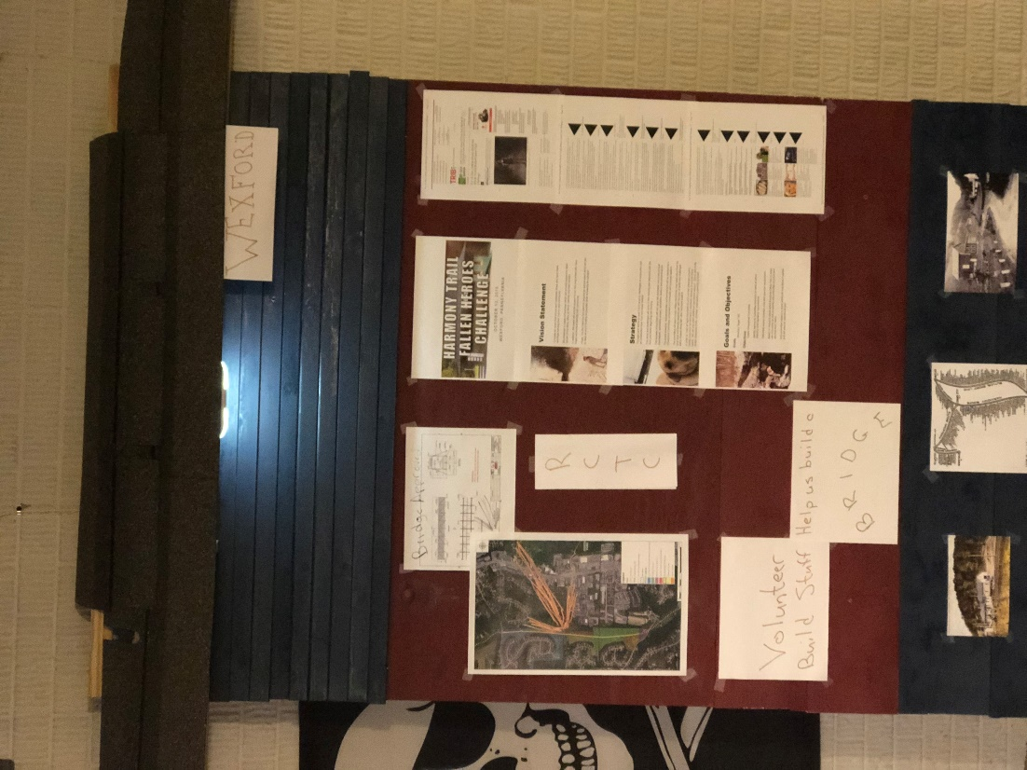

The proposed housing development at the corner of Brennan Road and Route 910 received conditional approval. There will be another public hearing because of the high level of concern about this development. If it goes through we may end up with a piece of land like our tract below Blue Heron. The developer will be required by Pine to surface the trail.

Gary Rigdon of the Friends of North Park invited us to lead a project during the Stewardship Day May 12, 2018 starting at 9:00 at the Ambridge Shelter on Pearce Mill Rd. He expects to have between 80 and 100 volunteers. He will assign a number to them to us. We need to come up with one or more projects and leaders.